High-Level Architecture & Risk Analysis

FYP-T4

1. Document Control
Field | Details
Project Title | A Hybrid Intelligent System for Patient Query Handling and Appointment Management with Guided Patient-to-Department Routing, Urgency-Based Escalation, and Structured Human Handoff Support
Group ID | FYP-2026-G2
Version | 1.0
Date | 11 June 2026
Prepared By | Ibtisam Saleem (SU/BSCS/201/2023), Faryal Israr (SU/BSCS/202/2023)
Supervisor | Ma’am Madiha Zaidi

2. Architectural Drivers
Architectural drivers are the key requirements, constraints, and quality attributes that influence the design of the proposed system.

2.1 Key Functional Requirements
Requirement ID | Functional Requirement / Feature | Architectural Impact
FR-1 | Guest Chatbot Access | Requires chatbot interface and query processing module
FR-3 | User Authentication | Requires authentication module, RBAC, and user database
FR-5 | Guided Patient-to-Department Routing | Requires intent processing and routing logic
FR-7 | Appointment Booking | Requires appointment module, schedule validation, and database storage
FR-10 | Appointment Approval Workflow | Requires reception staff dashboard and appointment management module
FR-13 | Urgency Classification | Requires urgency detection and escalation module
FR-14 | Escalation Management | Requires escalation records, notifications, and tracking
FR-15 | Human Handoff Summary Generation | Requires handoff generation module and summary storage
FR-19 | Administrative Management | Requires administrator dashboard and management modules
FR-22 | WhatsApp Integration (Optional) | Requires communication adapter layer and external service integration

2.2 Key Non-Functional Requirements

NFR ID | Category | Architectural Consideration
NFR-1 | Performance | Common operations such as query handling and appointment booking should complete within acceptable response times
NFR-2 | Usability | User-friendly interfaces should be provided for patients, reception staff, department staff, and administrators
NFR-3 | Security | Authentication, authorization, and input validation must be enforced
NFR-4 | Reliability | Appointment, escalation, and activity records must remain persistent
NFR-5 | Maintainability | System should be divided into independent modules
NFR-6 | Portability | Browser-based access should allow use without special installations
NFR-7 | Data Integrity | Backend validation should prevent duplicate appointments and invalid operations

2.3 Key Constraints
Constraint | Impact on Architecture
Limited academic development timeline | Architecture should remain modular but not overly complex
Simulated hospital database | Independent database design required
Browser-based access requirement | Web application architecture required
Optional WhatsApp integration | Core system must function independently
Limited real-world testing | Validation will occur within academic environment
No production deployment requirement | Focus on prototype-level implementation

2.4 Security Requirements
Security Requirement | Architectural Response
Authentication | Registered users must log in before accessing protected features
Authorization / RBAC | Separate permissions for Patients, Reception Staff, Department Staff, and Administrators
Input Validation | Backend validation for forms, appointments, and escalation actions
Data Protection | Password hashing and controlled database access
Session Handling | Authenticated sessions control access to protected pages
API Security | Protected backend routes and request validation
Invalid Operation Prevention | Duplicate appointments and invalid workflow actions will be rejected

3. Proposed High-Level Architecture
The proposed system follows a layered architecture that separates presentation, application logic, communication services, and data management.
The architecture consists of:

Client Layer
- Patient Interface
- Reception Staff Dashboard
- Department Staff Dashboard
- Administrator Dashboard

Frontend Layer
- HTML
- CSS
- JavaScript

Backend Layer
- Node.js
- Express.js

Core Application Modules
- Authentication & RBAC Module
- Chatbot Query Processing Module
- Intent Processing Module
- Department Routing Module
- Appointment Management Module
- Urgency Classification Module
- Escalation Management Module
- Human Handoff Summary Module
- Activity Logging Module

Data Layer
- MySQL Database

External Services
- Web Speech API
- Optional WhatsApp Integration

3.1 Architecture Diagram
Figure 1: Proposed High-Level Architecture
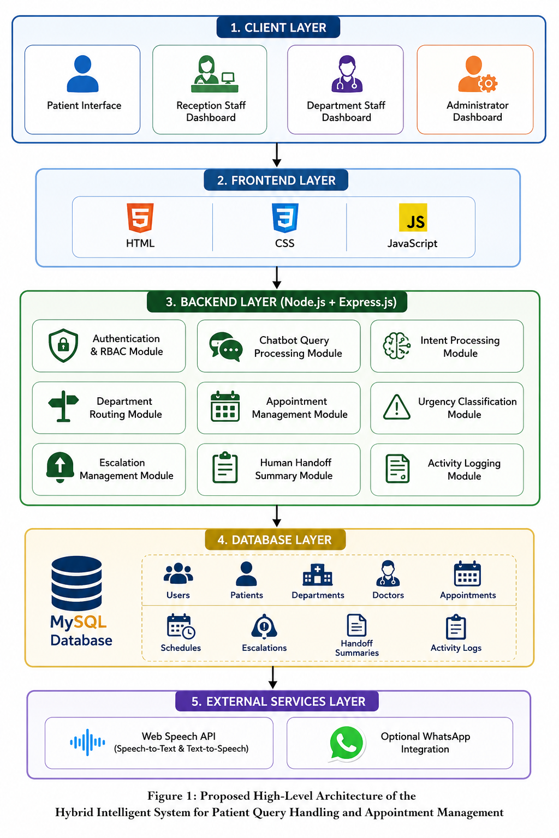

3.2 Architecture Description
Users access the system through a web browser using role-specific interfaces. Patients interact primarily through the chatbot and appointment management interfaces, while reception staff, department staff, and administrators access dashboard-based functionality.
The frontend communicates with the backend through HTTP requests. The backend contains the primary business logic, including query processing, intent classification, routing, appointment scheduling, urgency detection, escalation management, and handoff generation.
The database layer stores user information, appointments, departments, doctor schedules, escalations, summaries, and activity logs. Validation rules are enforced before database operations are performed.
External services such as the Web Speech API and optional WhatsApp integration are connected through dedicated communication layers without affecting the core system architecture.

4. Component Description
Component / Module | Purpose | Interfaces / Interactions | Owner / Responsible Student
Authentication & RBAC Module | Handles login, user verification, and permissions | User input → Authentication → User Database | Ibtisam Saleem
Chatbot Query Processing Module | Handles patient interactions and query management | Patient Interface ↔ Backend Logic | Ibtisam Saleem
Intent Processing Module | Identifies patient intent from queries | Chatbot ↔ Intent Logic ↔ Routing Module | Ibtisam Saleem
Department Routing Module | Recommends appropriate department | Intent Module ↔ Department Data | Ibtisam Saleem
Appointment Management Module | Handles appointment scheduling and validation | Patient Interface ↔ Appointment Database | Ibtisam Saleem
Urgency Classification Module | Determines urgency level of requests | Query Processing ↔ Escalation Module | Ibtisam Saleem
Escalation Management Module | Creates and tracks escalations | Urgency Module ↔ Staff Dashboard | Ibtisam Saleem
Human Handoff Summary Module | Generates summaries for staff | Escalation Module ↔ Staff Dashboard | Ibtisam Saleem
User Interface Module | Provides patient and staff interfaces | Browser ↔ Frontend Components | Faryal Israr
Dashboard Module | Provides monitoring and management functionality | Frontend ↔ Backend Modules | Faryal Israr
Database Layer | Stores all system data | Backend Queries ↔ MySQL | Ibtisam Saleem
Activity Logging Module | Records important actions and events | Backend Actions → Log Records | Both Students

5. Technology Stack
Layer / Area | Proposed Technology | Justification
Frontend | HTML, CSS, JavaScript | Lightweight and suitable for web-based interfaces
Backend | Node.js with Express.js | Efficient backend framework for web applications
Database | MySQL | Structured relational database suitable for appointments and scheduling
APIs / Services | Web Speech API | Supports voice interaction features
Communication Layer | Optional WhatsApp Integration | Additional communication channel
Deployment Platform | Local Server / Render / Cloud Hosting | Suitable for academic prototype deployment
Version Control | GitHub | Repository management and contribution tracking
Design / Modeling Tool | Draw.io | Diagram and architecture modeling
Testing Tools | Manual Testing, Browser Testing | Appropriate for prototype validation

6. Design Rationale
The proposed system follows a layered and modular architecture that separates user interfaces, application logic, communication services, and data management.
This architecture was selected because it supports the project’s major functional requirements, including patient query handling, department routing, appointment management, escalation workflows, and human handoff support.
The modular structure improves maintainability by allowing independent development and testing of components. It also supports future scalability by enabling additional communication channels or advanced processing features to be integrated without redesigning the entire system.
Node.js and Express.js provide a lightweight and efficient backend platform, while MySQL offers reliable structured data storage. The architecture remains intentionally simple to support academic implementation while maintaining sufficient extensibility for future improvements.

7. Risk Analysis

7.1 Risk Register

Risk ID | Risk Description | Category | Probability | Impact | Mitigation Strategy | Owner
R-1 | WhatsApp API approval not obtained | Technical | High | Medium | Use web-based chatbot as primary communication channel | Both
R-2 | Incorrect intent classification | Technical | Medium | High | Human escalation workflow and supervisor review | Ibtisam
R-3 | Appointment scheduling conflicts | Functional | Medium | Medium | Implement schedule validation and conflict detection | Ibtisam
R-4 | Scope expansion during development | Project Management | Medium | High | Strict adherence to approved requirements | Both
R-5 | Limited real hospital data availability | Resource | High | Medium | Use realistic simulated hospital database | Both
R-6 | Browser compatibility issues | Technical | Low | Medium | Cross-browser testing and validation | Faryal
R-7 | Development delays | Schedule | Medium | High | Follow sprint planning and milestone tracking | Both
R-8 | Security vulnerabilities | Security | Medium | High | Authentication, RBAC, input validation | Ibtisam
R-9 | Voice API limitations | Technical | Medium | Low | Treat voice features as enhancement module | Both
R-10 | Team coordination issues | Team | Low | Medium | Regular meetings and task tracking | Both

7.2 Risk Assessment Matrix
Impact / Probability | Low | Medium | High
High Impact | R-10 | R-2, R-7, R-8 | R-4
Medium Impact | R-6 | R-3 | R-1, R-5
Low Impact | - | R-9 | -

7.3 Risk Management Approach
The project follows a proactive risk management approach. Risks will be reviewed during supervisor meetings and sprint reviews. Any new risks identified during development will be documented and mitigation plans will be updated accordingly.

8. Security Considerations
The system handles user accounts, appointments, escalation records, and administrative functions. Therefore, security is an important architectural consideration.

8.1 Authentication
- Login required for appointment booking and tracking.
- Guest users may access chatbot functionality.
- Secure authentication mechanism for registered users.

8.2 Authorization (Role-Based Access Control)
Role | Access Rights
Patient | Book appointments, track appointments, interact with chatbot
Reception Staff | Manage appointments, handle escalations
Department Staff | Review escalated cases and summaries
Administrator | Full system management

8.3 Data Protection
- Password hashing before storage.
- Controlled database access.
- Sensitive records accessible only to authorized users.

8.4 Input Validation
Validation shall be applied to:
- Registration forms
- Appointment requests
- Escalation forms
- Administrative actions
to prevent invalid data entry.

8.5 Activity Logging
The system will record:
- User login activity
- Appointment actions
- Escalation actions
- Administrative actions
to support monitoring and auditing.

9. Hardware / Environment Requirements

9.1 Development Environment
Component | Specification
Processor | Intel Core i5 or equivalent
RAM | 8 GB minimum
Storage | 20 GB free disk space
Internet | Required for GitHub and testing

9.2 Software Environment
Component | Technology
Operating System | Windows 10/11 or Linux
IDE | Visual Studio Code
Frontend | HTML, CSS, JavaScript
Backend | Node.js + Express.js
Database | MySQL
Version Control | GitHub
Diagram Tool | Draw.io
Documentation Tool | Microsoft Word

9.3 Deployment Environment
The prototype may be deployed using:
- Local Development Server
- Render
- Railway
- Other cloud-based hosting platforms

10. Architecture Assumptions and Limitations

10.1 Assumptions
- Patients have internet access.
- Staff members have browser access.
- Simulated hospital data accurately represents real workflows.
- Users provide accurate information during interactions.
- Supervisor-approved scope remains unchanged.

10.2 Limitations
- No real hospital database integration.
- No emergency medical diagnosis functionality.
- WhatsApp integration is optional.
- Voice functionality depends on browser support.
- System is intended for academic prototype purposes.

11. Traceability to Requirements
Requirement Category | Architecture Component
User Authentication | Authentication & RBAC Module
Patient Queries | Chatbot Query Processing Module
Intent Recognition | Intent Processing Module
Department Recommendation | Department Routing Module
Appointment Booking | Appointment Management Module
Urgency Detection | Urgency Classification Module
Escalation Handling | Escalation Management Module
Human Handoff Support | Human Handoff Summary Module
Activity Tracking | Activity Logging Module
User Management | Administrator Dashboard
Voice Support | Web Speech API
WhatsApp Communication | Optional WhatsApp Integration Layer

12. Internal Review Checklist
Review Item | Status
Architecture aligns with approved scope | ☑
Major functional requirements covered | ☑
Security considerations documented | ☑
Technology stack finalized | ☑
Risks identified and mitigated | ☑
Architecture diagram prepared | ☑
Component responsibilities defined | ☑
Traceability established | ☑
Supervisor review completed | ☐
Ready for Checkpoint-1 submission | ☐

Conclusion
The proposed architecture provides a modular, scalable, and maintainable foundation for the Hybrid Intelligent System for Patient Query Handling and Appointment Management. The architecture supports guided routing, appointment management, urgency-aware escalation, and structured human handoff workflows while maintaining security, flexibility, and future extensibility. The identified risks have been analyzed and mitigation strategies have been defined to improve project success and implementation reliability.

